Gilda’s Club Westchester

YOUTH COMMITTEE

Handbook: 2023-2024

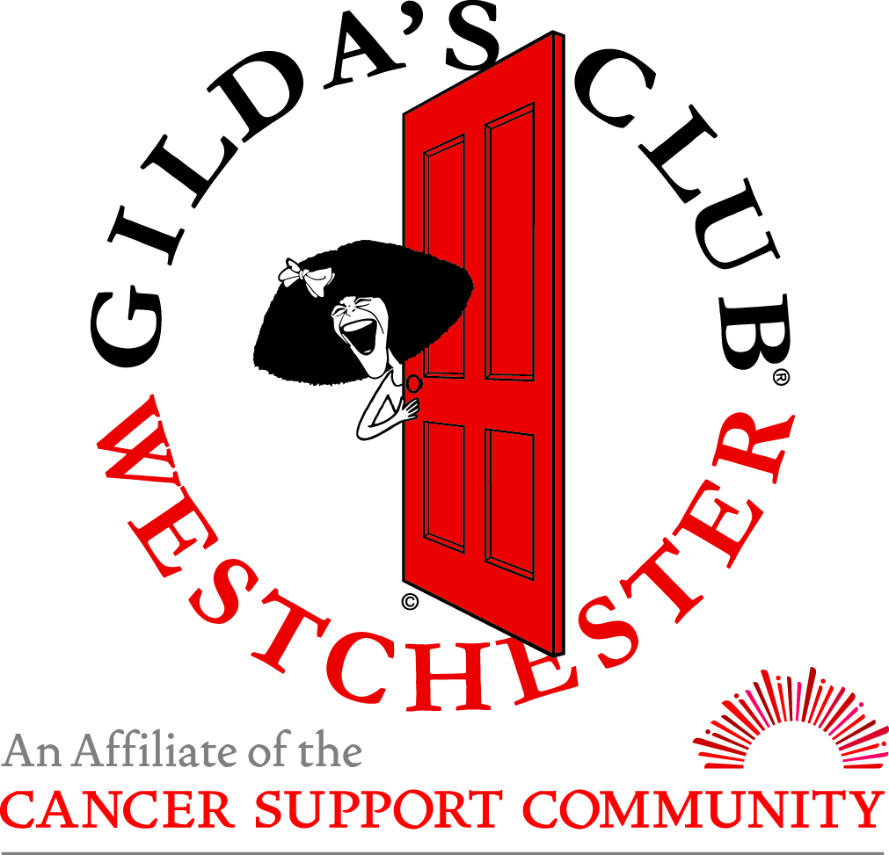

Gilda’s Club Westchester
80 Maple Avenue, White Plains, NY 10601
Phone: 914.644.8844 Fax: 914.644.8284
www.gildasclubwestchester.org

Gilda’s Club Westchester
Youth Committee

Thank you for your interest in Gilda’s Club Westchester Youth Committee!

The Youth Committee is a volunteer group of high school students from Westchester, Rockland, and lower Fairfield counties, whose goal is to raise awareness of the importance of cancer support and Gilda’s Club Westchester in their schools and communities.

Youth Committee members work together to plan events, fundraise, develop and distribute outreach and marketing materials, and find new and innovative ways to spread the word about GCW. Meetings are hands on and focus on learning about cancer, emotional support and the organization and operation of non-profit organizations. By the end of the year, members leave with an understanding of the inner-workings of a non-profit.

Many Youth Committee members join the group early on in high school, and stay through their senior year. It is a priority to foster connection among the members, schools and GCW.

We are excited to have you join us. Please carefully read through this packet and then, if you are interested in joining the Youth Committee, complete all the required paperwork no later than September 13th.

Warmly,

Jen

Jennifer Ricca, MS, CCLS Children, Teens, and Family Manager
jricca@gildasclubwestchester.org

GCW Youth Committee Overview

Committee Goals
- Support children and families impacted by cancer by assisting at events hosted by GCW.
- Learn leadership skills and how to work with a team through various projects, team building, and setting personal goals for the year.
- Educate your school community about the importance of educational and emotional support for people who are impacted by cancer and about GCW.
- Learn about the aspects of planning and implementing a special event geared toward teens. Engage peers and fundraise for the event and GCW.
- Understand the inner workings of a nonprofit organization through monthly educational components at meetings (i.e. program, development, volunteers, etc.)

Primary Requirements
- The Youth Committee meets one Sunday a month from 10-11:30 PM. The meetings will be in-person. Three meetings will be replaced with YC volunteer events. More information to come.
- Members must attend a minimum of 5 meetings (not including events) to remain members of the Youth Committee in good standing.
- Committee members are asked to volunteer at a variety of events throughout the year. These may include general GCW events or for our Children, Teens, and Families Program – see the calendar for dates. More information to follow at the first meeting.
- Every Youth Committee member will serve as an outreach liaison to their high school. Members will conduct a GCW outreach and awareness activity at their high school.
- Youth Committee members are invited to assist with other volunteer opportunities in the clubhouse (e.g. mailings, organizing, Gilda’s Dinners, Family Time Events, etc.).

Handbook Checklist

The Youth Committee Application and Handbook consists of the following three parts, and all must be completed by September 13th. The completed handbook can be emailed, or mailed to:

Jennifer Ricca, jricca@gildasclubwestchester.org

Gilda’s Club Westchester
80 Maple Avenue
White Plains, NY 10601

____________________________________________________________________

☐ Youth Volunteer Application
(completed on Google form https://forms.gle/a8cejBu414QPExEt6)

☐ Youth Committee Contract

☐ Photo Release

Meeting Calendar 2023-2024

September 13th Application/Handbook Due

October 1 10-11:30 Welcome Meeting

October 22, 9-12- Event FitFest Event at Saxon Woods

October 29 12-4 Event Noogiefest Halloween Bash

November 29, TBD - Event Holiday Boutique

December 17, 10-11:30 am YC Meeting

January 21, 10-11:30 am YC Meeting

February 25, 10-11:30 am YC Meeting

March 24, 10-11:30 am YC Meeting

April 28, 10-11:30 am Party/Recognition Ceremony

COVID-19 In-Person Meeting Policies

The following are GCW policies for in-person meetings and events. These policies are in place to protect the health and safety of staff, volunteers, and members, especially those with compromised immune systems. These policies are subject to change.

Illness/Exposure to COVID-19
- If a YC member in the last 14 days has been in contact with someone who tested positive for COVID-10 and/or a person exhibiting symptoms related to COVID-19, they should remain at home.
- If a YC member or anyone in their household is feeling ill or exhibiting other symptoms, they should remain at home.

Gilda’s Club Westchester Youth Committee Contract

Following are the requirements for participation in the Youth Committee. Before submitting your contract, please think about your desire and ability to commit to the Youth Committee (and any prior responsibilities scheduled on Sunday mornings - i.e., sporting events, religious obligations, work, SAT classes, etc. – that may prohibit your participation).

Members will:
- Participate in activities related to meeting the Youth Committee goals outline above.
- Attend at least 5 of the 9 meetings (not including events) scheduled during the 2023-2024 academic year (calendar of meetings enclosed in Youth Committee Handbook).
- Read Youth Committee email updates in a timely fashion and respond promptly when needed.
- Volunteer at a GCW event or another CTF event
- Complete and submit ALL components of the application by September 13th
- Agree to meet with the Youth Committee Coordinators for a review of commitment if they are unable to meet all obligations as outlined above (this may result in your termination from the committee).
- Agree to attend the meeting on time and be an active participant.

By signing this contract you agree to follow the commitments outlined above.

Student Signature Click or tap here to enter text. Date Click or tap here to enter text.

Printed Name Click or tap here to enter text.

Parent Signature Click here to enter text. Date Click or tap here to enter text.

Printed Name Click or tap here to enter text.

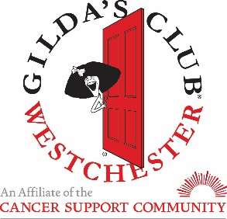

Dear Parent or Guardian,

We would like to take this opportunity to welcome your child and family to the Youth Committee at Gilda’s Club Westchester. Gilda's Club Westchester is a free cancer support community where men, women, and children living with cancer, and their families and friends, join with others to build social and emotional support.

Your child has signed up to participate in the Youth Committee of Gilda’s Club Westchester. The Youth Committee is a volunteer group comprised of high school students from area high schools whose goal is to plan events in the community and their own schools to raise awareness of the importance of cancer support and Gilda’s Club. The Youth Committee has been a valuable part of Gilda’s Club Westchester’s community for over 18 years.

Lastly, on the following page you will find a Photo Release. Please fill out the release, and have your child return it to Gilda’s Club with the other paperwork in this packet.

If you have any questions regarding the Youth Committee at Gilda’s Club Westchester, please do not hesitate to email me at jricca@gildasclubwestchester.org. If you would prefer to be called, please just call (914) 644-8844 and leave a message for me.

Thank you for allowing your children to be part of such an important mission!

Sincerely,

Jennifer Ricca

Photo/Video Release

I, Click here to enter text. give permission for photos and/or videos of my child, Click here to enter text.
(Parent or Guardian’s name) (Child’s name)

taken at Gilda’s Club Westchester to be used in the following manner:

Check any or all of the statements below:

☐ PHOTOS: for use in and around the Clubhouse (to be posted on Clubhouse bulletin boards).

☐ PHOTOS: for use in Gilda’s Club Westchester’s newsletters, outreach/fundraising publications, and/or websites.

☐ PHOTOS: for use in television or news publications.

☐ PHOTOS: for use on Gilda’s Club Westchester’s Facebook page.

☐ VIDEOS: for television or news publications; outreach purposes (i.e. schools and
community organizations); fundraising events; website purposes; and to be shown at Gilda’s Club Westchester to members.

Or:

☐ I do not wish to have my pictures or videos of my child used in any of the forums
listed above.

Signature: Click here to enter text. Date: Click here to enter text.

